Lesson 3
3:45/4:45 Class:
Now the kids are doing what we call the pre-twinkle phase. The students are learning a healthy foundation of basic skills so that in future play as easy as they can. This includes being able to do basic movements with an organic freedom in both hands, hold the violin and the bow properly, identify instruments parts, and play open strings with good sound, posture and bow hold. These are our goals until the end of this year. We are glad with the improvement of everybody; so far a lot were learned. Please help your child practice this week, about 8 minutes every day will reinforce these concepts.
Please review class materials for more information about the follow items:
-Rest position
-Statue of Liberty
-Play position
Keep practicing it, step by step, at least twice during each practice time.

Bow hold:
Now our students are learning how to hold the bow. This can be practiced with a pencil or the bow. Pencils are light weight, compare with the bow, so it’s good to start with that.
Make sure:
-The hand is hold the bow gentile, do not squeeze or tighten the finger on the bow
-All the fingers are curved, the thumb is bent and there is a natural space between the fingers (see the pictures)
-We are using "magic marks" to draw where the bow goes, so once the hand is upside down it is possible to see if the bow is in the correct place.
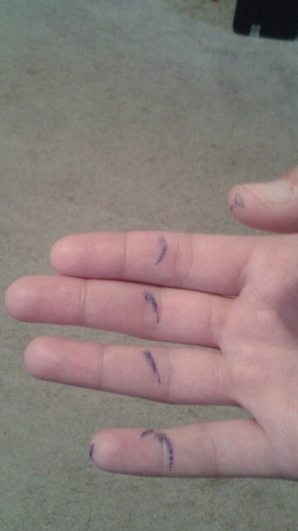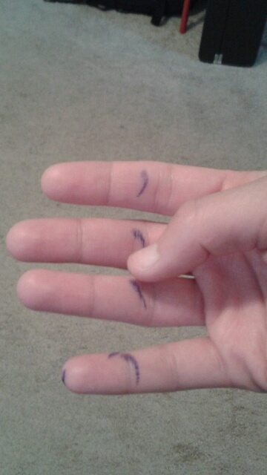
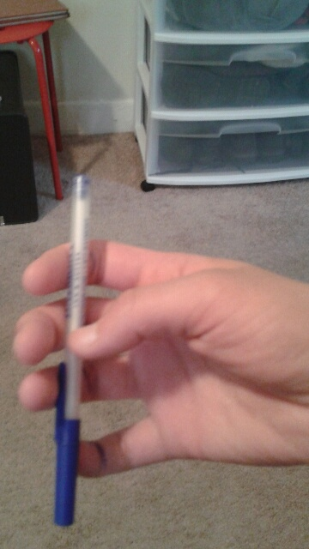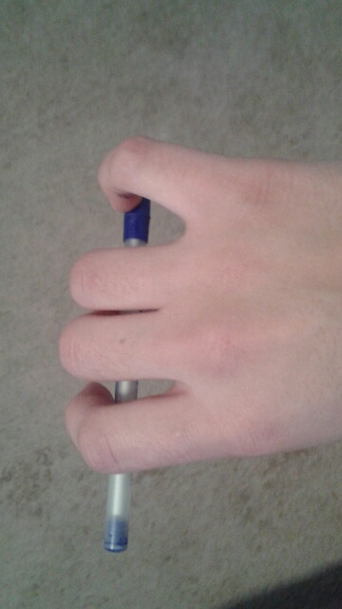
Music:
-Continue Eggs, (I highly recommend you help the kid play, guide his/her finger once to play the song and let the kid to do by him/herself after) pluck with the pinky finger, let the strings ring.
-New song: GDG
G D G rest,
G D G rest,
G G D D,
G D G rest

http://www.youtube.com/watch?v=Zsdm5Lc0Lu8
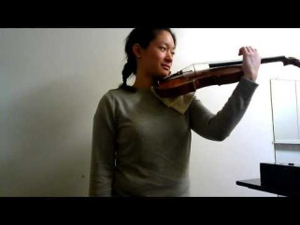 | GDG Song - YouTube  This video was uploaded from an Android phone.  Watch now...
During the rest stamp the right foot.
Finger attached in the string and pulled, let the string ring, sing along :D
Any questions please get in touch with me: dsdacruz@valdosta.edu

4:15/5:15 Class:
-We began with stretching exercises. We won't have time to do this every class. But I want the students to know it's important to be as relaxed as possible when playing the instrument.

- Next we reviewed rest position to playing position. See notes from last week. Most students had put in some time on this which was shown in their improvement over the two weeks. A few were still confused about a couple steps, and mostly finding the comfortable place for the violin to rest on the collar bone of the left shoulder in the last step. The violin should not go below the shoulder line when bringing it into playing position. And make sure that the violin comes to you; don't bring yourself to the violin. Keep shoulders relaxed. And once the violin is in a comfortable secure place then rest your cheek on the chin rest, slightly tilting your head to the left. The violin should feel comfortable!! Experiment with it in slightly different positions until it feels the best for you. All the meanwhile, your left hand should be covering the high dot.
-Next we played Pop Goes the Weasel, in which the students must pluck the E string with their pinky finger on the word "Pop" in the song. This is a fun game for the kids and keeps their concentration while working on playing position and plucking the E string.
-Next we reviewed EGGS- plucking each string from highest to lowest three times in a row. I was having a hard time with the students plucking together. Try to practice doing this in time at home. Pluck, pluck, pluck, rest... and then pluck, pluck, pluck, rest, etc... Have students try marching to a rhythm as they practice and actually say the word rest when not plucking on the fourth beat.
-Next we practiced plucking different strings in different rhythms. This was mostly for me to test their ears. Overall, the students did fairly well at this.

-Rhythm Taps
-Warm up by waving your left hand over the high dot at yourself. Then practice tapping the fingerboard lightly, but enough to make an audible sound. We practiced 4 tapping rhythms together:
Mississippi Hot Dog; Pop Corn and Candy; Cheeseburger; and Strawberry. We will go over the rhythms at the beginning of next class again, but students should have a good memory of they go. Each word or phrase represents a rhythm. Mississippi Hot Dog is 4 16th notes an 2 eighth notes. Pop Corn and Candy is eighth, eighth, eighth rest, eighth, eighth, eighth, eighth rest, eighth, eighth, eighth, eighth rest, etc… Cheeseburger is eigth- sixteenth-sixteenth. And finally Strawberry is straight triplet (equal) eighth notes. Some of this rhythm language will be a little confusing for most of you. But for those parents who are musically inclined, knowing these rhythms will help you practice with your kids.

-4:15 class only-
Beginning bow hold on the pencil and exercises (see attached photos):
-Make an A-ok symbol between your bent thumb and and your first inside knuckle of of your middle finger. This is the center
of your grip.
-Place pencil between connection of thumb and middle finger. Make sure your wrist and arm are straight and relaxed when
doing this. Fingers should be facing the ground.
-Let other fingers hang over and put pinky on top of the pencil (later the bow.)
-Very important to remember two main things- Keep your thumb bent outwardly underneath the fingers. Only the tip of the thumb should touch the pencil. And make sure pinky is bent and curved on top of the pencil.]
-See attached photos this will help!
2 Pencil exercises:
-Teeter Totter- try to execute this with the wrist first. Tilt pencil to left, straight, then right, then straight, left… etc. Next try to execute this with the fingers only. This is hard. Release weight of pinky on top, let pencil fall left. Then push pinky back down on pencil to ben right, etc…
-Straight fingers to flat knuckles. This exercise was a little complicated. We will try it more next week. Preparation: without pencil, make a fist, then flatten knuckles. Then bend fingers straight down to floor, forming L with palm and fingers, and then back to flat knuckles. Once you've mastered this, try it with a pencil in your hand, moving it up and down only with the fingers in this way.
